Dataset Link:
https://itv-contentbucket.s3.ap-south-1.amazonaws.com/Exams/Tableau/insurance.xlsx

By Using insurance.csv file attempt the following.
- Create donut chart for incident severity which shows percentages of policy annual premium.
Ans:
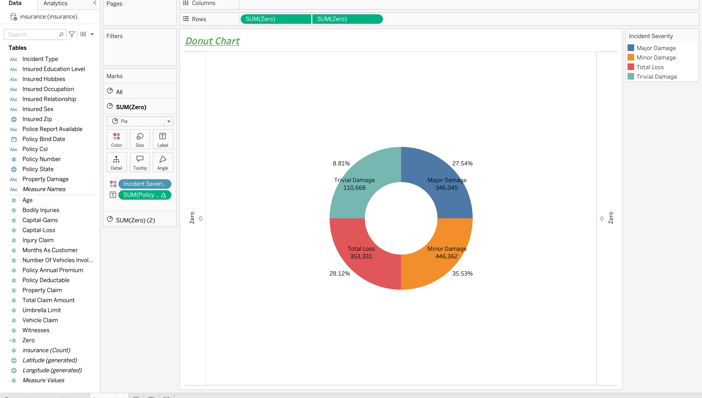

- Create bullet graph Gender wise Capital gain , which also shows 60%,80% and average property claim.
Ans:
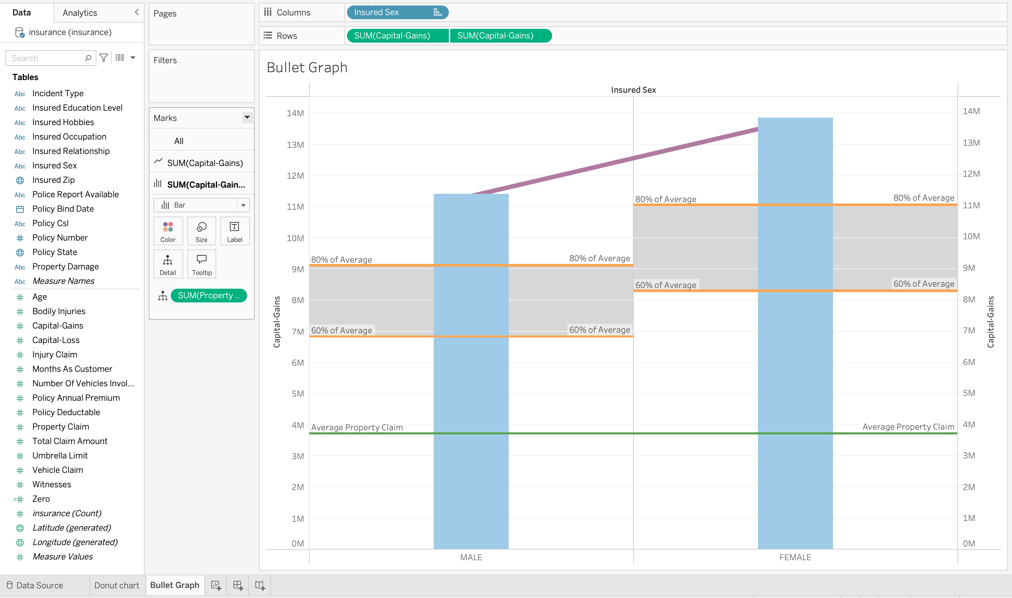

- Create motion chart which displays total claim amount vs policy deductible for each auto model
Ans:

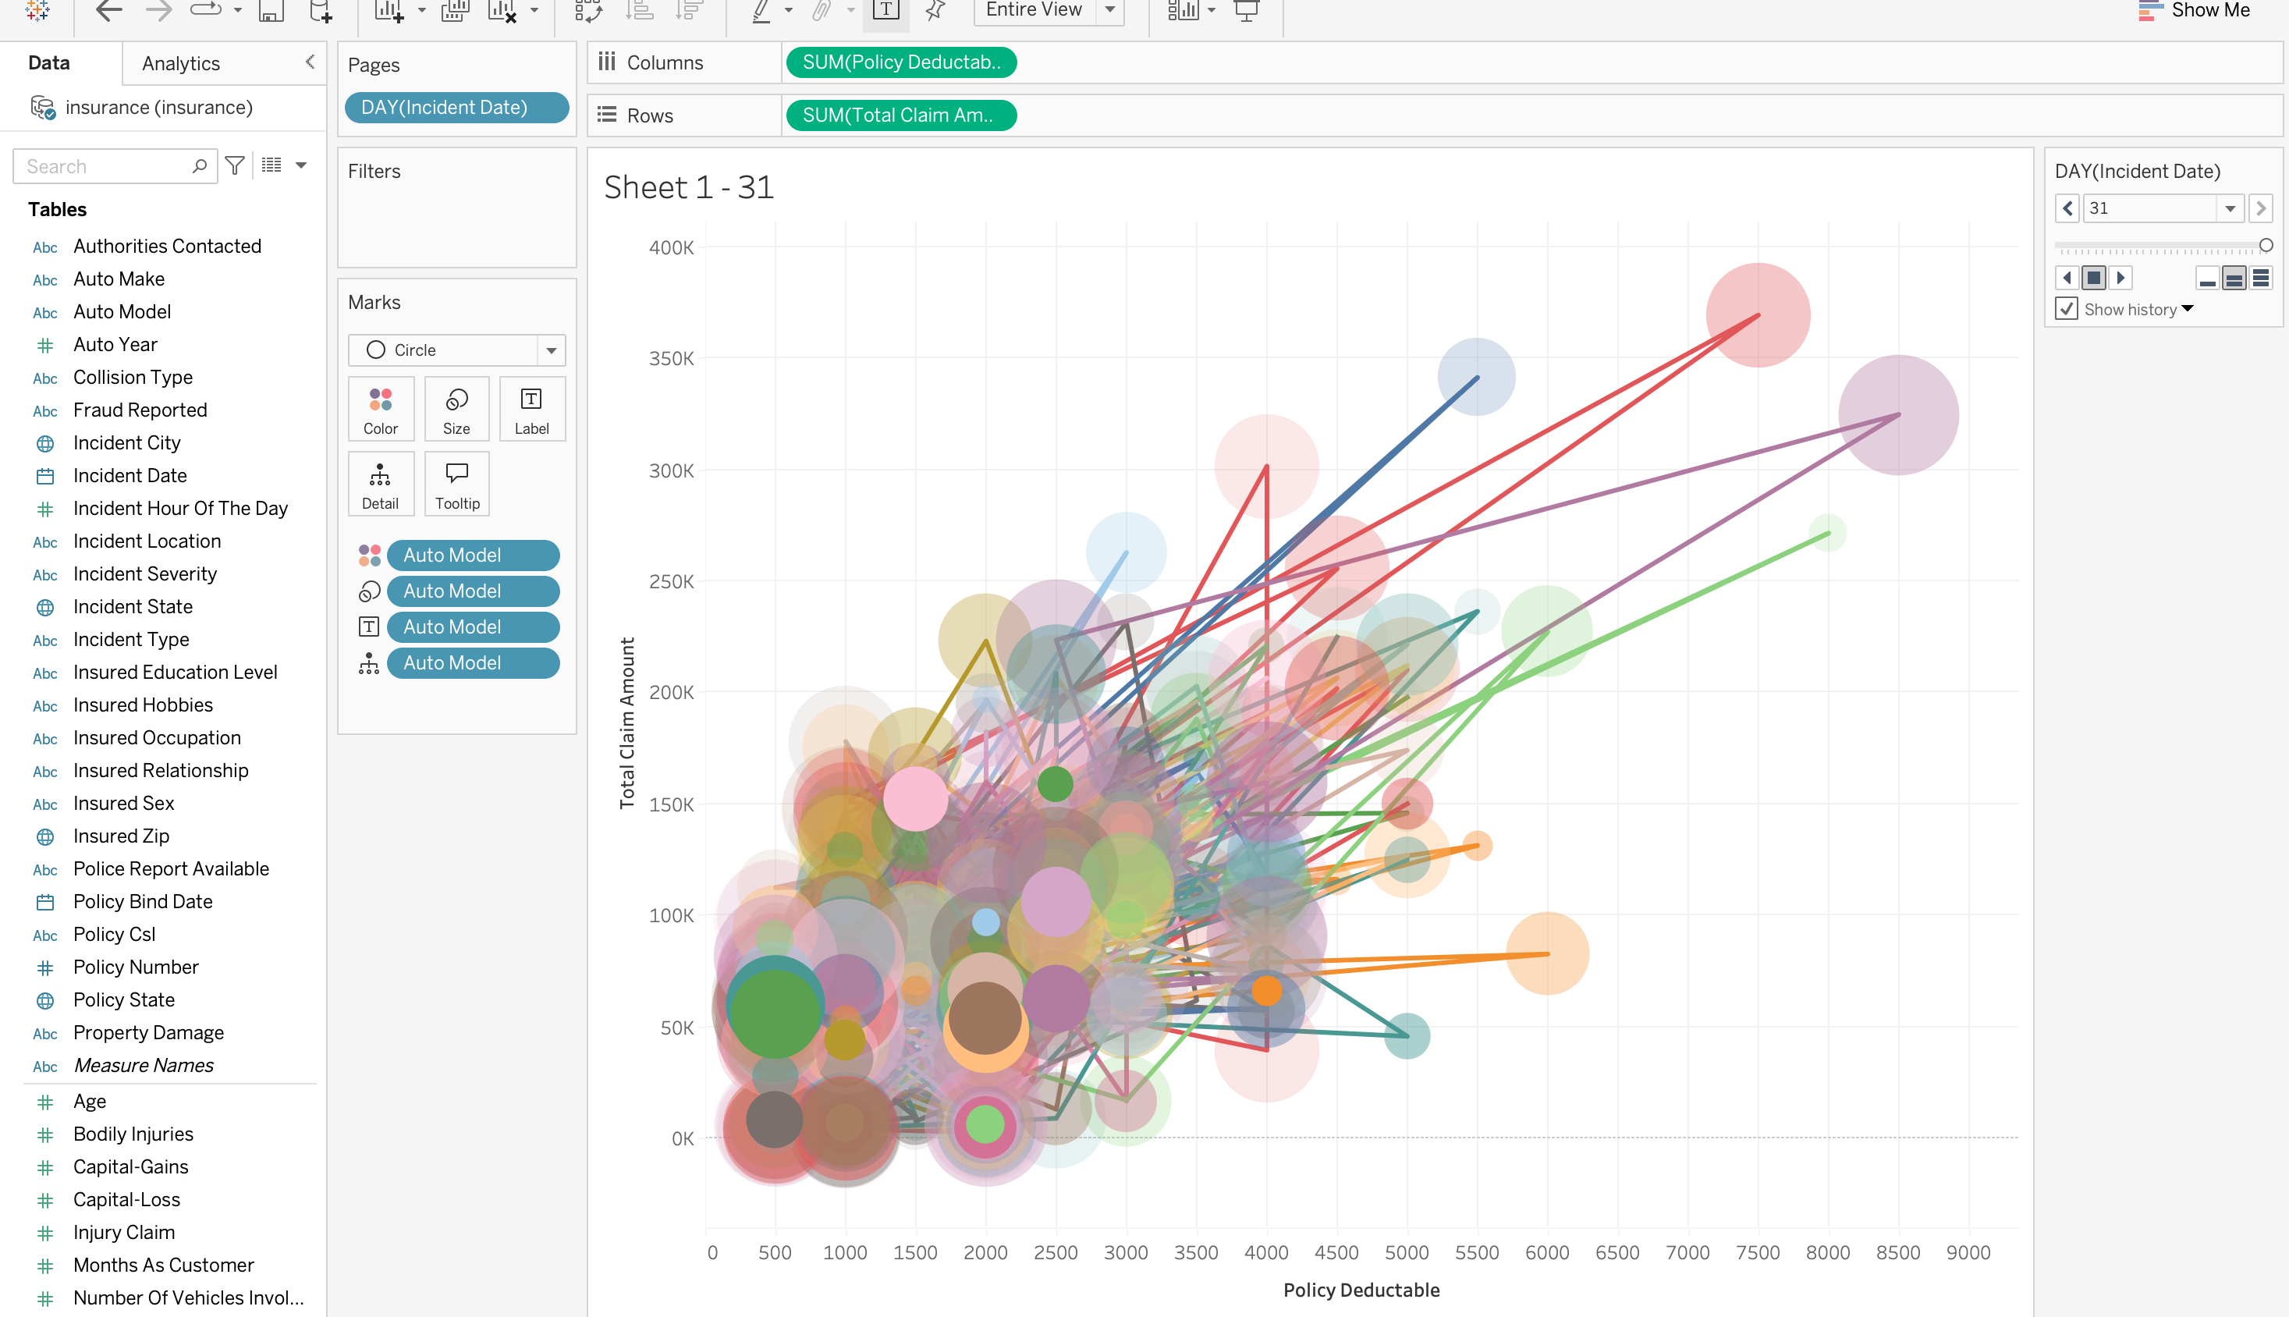
- Compare all KPIs in the given dataset.
Ans:
